https://miktex.org/howto/install-miktex:

Install MiKTeX on Windows (miktex.org)
Last edited: 2/6/2018 10:13:34 AM
To set up a basic TeX/LaTeX system, download and run the Basic MiKTeX Installer. MiKTeX has the ability to install missing packages automatically, i.e., this installer is suitable for computers connected to the Internet.
Before you run the installer, you should check the prerequisites.
If you want to deploy MiKTeX in your organization, it is recommended that you use the MiKTeX Setup Utility to install MiKTeX silently on the client computers. Please read this how to, for a step-by-step recipe.
Table of Contents
Install MiKTeX on Windows (miktex.org) 1
Running the Basic MiKTeX Installer 2
Copying conditions 2
Installation scope 2
Installation directory 3
Settings 3
Review 4
Installation progress 5
Finish 5
Getting updates 5

Running the Basic MiKTeX Installer
The "Basic MiKTeX Installer" is used to set up a standard TeX/LaTeX system. The installer is available on the download page. You start it with a double-click on the downloaded file.

Copying conditions
The wizard first shows the MiKTeX copying conditions:
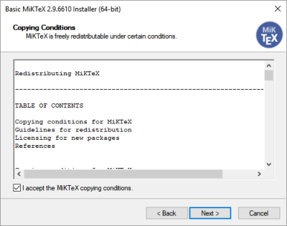
Read the text carefully and click I accept the MiKTeX copying conditions, if you agree. You can then click Next, to go to the next page.

Installation scope
If you have administrator privileges, you can choose between two options:
- Set up a private (per-user) TeX installation.
- Set up a shared (system-wide) TeX installation.
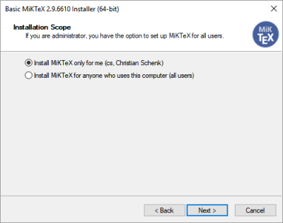
It is highly recommended that you choose a private installation.
Setting up a shared (system-wide) installation requires administrator privileges and you should keep in mind that maintaining a shared installation can become complicated and error prone.
When you have made your decision, click Next to go to the next page.

Installation directory
You can accept the default MiKTeX installation directory. If you want, you can specify another location.
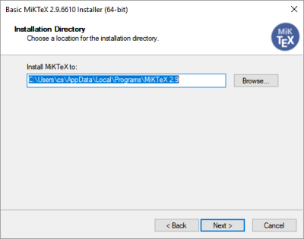
Click Next, to go to the next page.

Settings
The wizard allows you to set the preferred paper size:
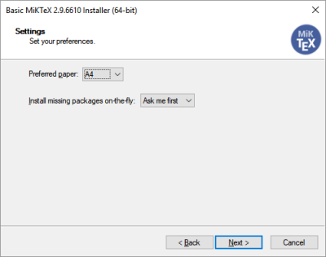
You also have the option to change the default behavior of the integrated package installer. Select Ask me first, if you want to confirm installation of required packages. Select Always, if required packages are to be installed without confirmation. Select Never, if you disallow the installation of missing packages.
All the preferences can be changed later.
Click Next, to go to the next page.

Review
Before the actual installation process begins, you get a chance to review your decisions:
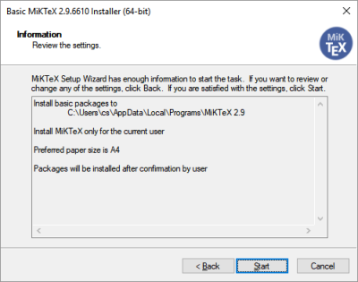
If you are satisfied with the settings, then click Start to start the actual installation.

Installation progress
The installation will take a few minutes. The progress bar shows an approximate percentage of completion:
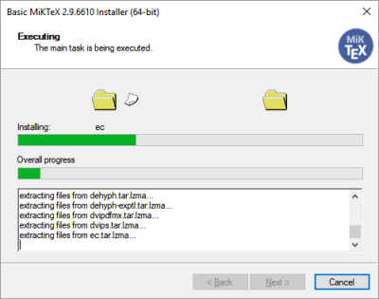
When the installation has finished, you can click Next to open the last wizard page.

Finish
MiKTeX is now installed:
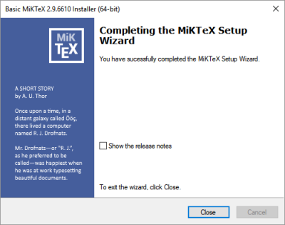
Click Close, to close the exit the wizard.

Getting updates
It is recommended that you start MiKTeX Console now and check for updates.

